**MySQL Runtime for Windows**

1. Click the Windows icon on the bottom left corner of the screen.
2. Click the MySQL 8.0 Command Line Client icon.

1. Run the MySQL executable
2. Type “help”

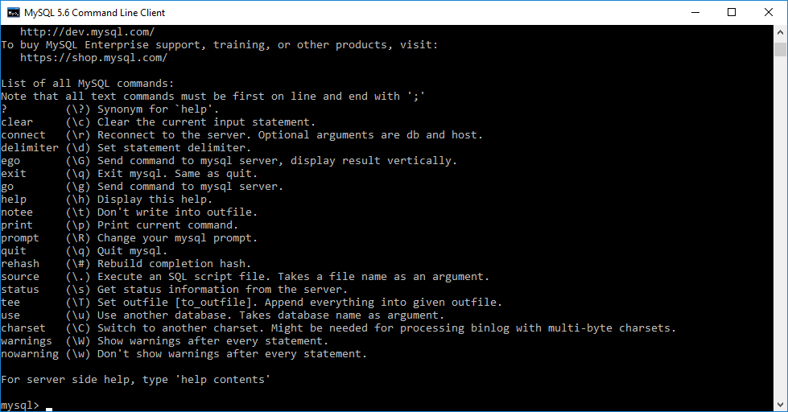

1. Type “show databases;”

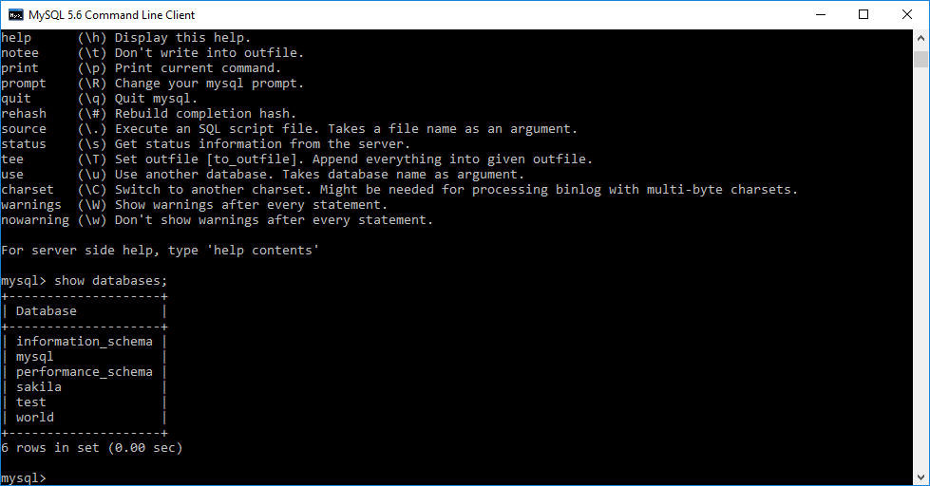

1. Type “use world”

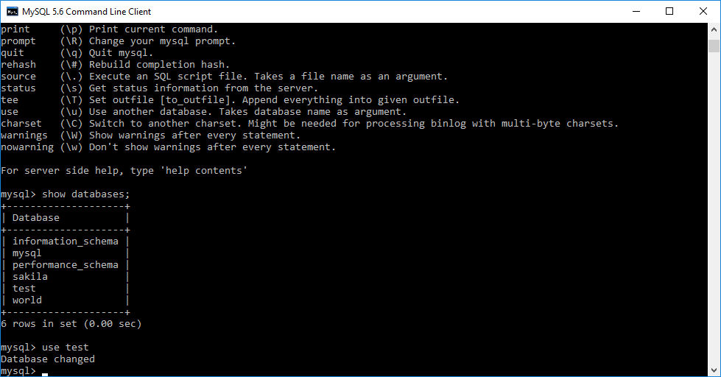

1. Type “show tables”

